MODULE: 13 | LESSON: 2 | AREA OF TRIANGLES

Triangle | 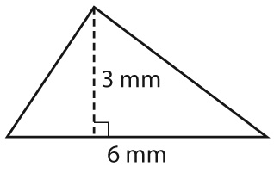 | A = $\frac{bh}{2}$ | A = $\frac{6 x 3}{2}$  = $\frac{18}{2}$  = 9mm²

